June 22, 2018
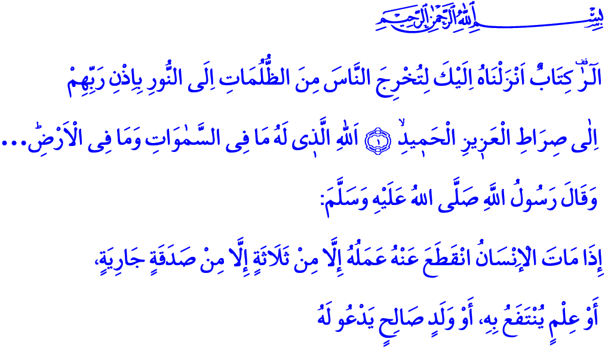SUMMER COURSES OF QUR’AN AND THEIR IMPORTANCE
Jumu’ah Mubarak Honorable Brothers and Sisters!

In the verse I have recited, Our Lord Almighty enjoins, “Alif, Lam, Ra. [This is] a Book which We have revealed to you, [O Muhammad], that you might bring mankind out of darknesses into the light by permission of their Lord - to the path of the Exalted in Might, the Praiseworthy - Allah, to whom belongs whatever is in the heavens and whatever is on the earth.…”
And in the hadith I have read, our Beloved Prophet (s.a.w.) says, “When a man dies, his acts come to an end except for three: sadaqah jariyah (ceaseless charity), knowledge by which people benefit, or a pious descendant, who prays for him.”
Brothers and Sisters!
Our Lord Almighty has bestowed an excellent book upon humanity through our Prophet –Mercy to the Worlds. This book has taught us the reason of our creation and the purpose of our existence. It heralded us that life would find meaning with faith and humankind would be exalted with servitude to Allah. Believers have instilled this book in their minds and hearts for fourteen centuries. They have committed themselves to it with a steadfast faith and a profound attachment. This book is the Holy Qur’an–our guide for the truth and the formula for salvation.
Honorable Believers!
The Holy Qur’an is the greatest gift from Our Almighty Lord to us, believers. The Holy Qur’an is the most exalted trust from our Beloved Prophet (s.a.w.). Therefore we, as believers, illuminate our minds and hearts with its light. We build our present and future under its guidance. We strive to teach our children –the light of our life– its merciful messages, its halals and harams.
Because we know that our children are the greatest trusts from Allah Almighty. It is the most important duty for all parents to raise them as generations who are conscious of themselves and their Lord, who are aware of their responsibilities, who are beneficial to their nation and the humanity. As enjoined by this hadith of our Prophet (s.a.w.), “There is no gift that a father gives his child more virtuous than good manners.” Our biggest inheritance for our children is to teach them about faith and Islam, and to equip them with good morals.
Brothers and Sisters!
Another period of time is starting to raise dutiful generations, and to introduce our children –apples of our eyes– with the Qur’an and the exemplary life of our Prophet (s.a.w.). Our Qur’an courses will start on June 25 and continue until August 17. Our mosques will become a home of education for millions of children with the motto “Sound of Children at Mosque, Joy of the Country.”
Our children will be more acquainted with our Lord. They will instill faith and Islam in their taintless hearts. They will know the Holy Qur’an and the exemplary life of our Prophet more closely. They will grasp deeper integrity and honesty, compassion and mercy, love and respect, fairness and justice, sharing and solidarity, brotherhood and affection, in short, moral values, as commanded by the Qur’an and exemplified by the Prophet with his actions. They will feel the value of loving books, the importance of reading and science. They will meet at mosques, which are symbols of our independence. They will hear even closer the adhan – the vibrant sound of unity. They will learn worshiping to protect their tender minds and immaculate nature from evils.
Dear Muslims!
Let us take advantage of summer Qur’an courses to be started at each mosque. Let us, as parents, encourage our children to attend these courses! Let us not deprive them of the light of the Qur’an. Let us strive to become examples for our children to read and understand the Qur’an, to ponder and draw lessons from it, and to make it our guide in our life. Let us strengthen our ties with books, and add peace and wisdom in our lives thanks to the reading halls. Let us exert ourselves to raise generations who shape their lives by following our Holy Book and our Prophet.
I would like to conclude this khutbah with the following hadith from our Prophet, “The best of you is he who learns the Qur’an and teaches it.”

Ibrahim, 14/1-2.
Muslim, Wasiyyah, 14.
Tirmidhi, Birr, 33.
Tirmidhi, Fadhail al-Qur'an, 15 General Directorate of Religious Services

